**Will a Computer Diagnose Your Next Heart Attack?**

Author Bios:

Wilson W. Good is a senior PhD researcher with joint appointments at the Scientific Computing and Imaging (SCI) Institute and the Nora Eccles Cardiovascular Research and Training Institute (CVRTI) in the field of cardiac electrophysiology. Wilson has presented on this research at several international conferences and the research is currently in preparation.

Brian Zenger is a MD/PhD researcher at the Scientific Computing and Imaging Institute, Nora Eccles Cardiovascular Research and Training Institute, and the University of Utah School of Medicine in the field of cardiovascular disease.

Article:

*You are working in your house, going about your normal routine when suddenly the pain hits. You chest starts to throb and your left arm begins to ache. Without hesitation you rush to the hospital, dreading your worst fear has become a reality – you are having a heart attack. Upon arrival, physicians, nurses, and other medical staff begin frantically testing, probing, and prodding nearly every part of your body. They run more tests than you can keep track of and begin shouting orders for new tests and other members of the team. The physician is carefully watching the monitors hooked up by your bedside, puzzled by the results they are seeing. He turns to consult an expert on the signals your heart is emitting but instead of a person they turn to a computer.*

Heart Attacks and Heart Attack Detection:

Everyday in the United States more than 2,000 people have heart attacks. Of these, over 400 people do not receive treatment in time. A heart attack occurs when the arteries supplying blood to your heart are clogged with material. Without blood, the heart does not have the necessary nutrients to continue functioning normally and begins to die. The longer a patient waits, the more likely there will be irreparable damage to the heart. While advancements have been made in heart attack detection the underlying methods are unchanged from a century ago. Currently physicians use the same electrocardiograms (ECGs) developed in the late 19th century to monitor the electrical activity of the heart. Depending on the location and severity of the heart attack certain regions of the ECG may change. However, these changes are small, unreliable, and only include a small portion of the entire electrical signal of the heart.

Researchers have tried, to no avail, to apply different signal processing and other complicated mathematical manipulations. These processing steps, and others, have been unable to compensate for each heart in each person being different. Just like your fingerprint, your heart has a slightly different shape, different beating force and thus a different resting signal. Not to mention the space between the heart and the recording device on the body surface can vary greatly with weight, gender, and overall body type. These variations make it very difficult to automated systems to predict what your specific heart is going through at any given moment. The necessitates a new system, that can change based on your unique heart shape and signal, to detect whether or not you are having a heart attack.

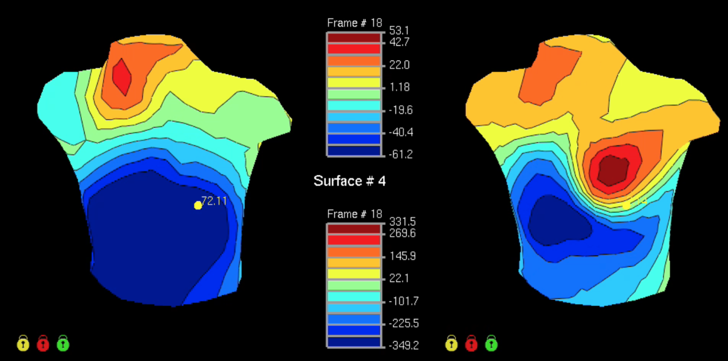

~CAPTION~ The colors represent the potential values distributed across the body surface at a single point in time. LEFT: Healthy body surface potentials. RIGHT: Electrical potentials created by the heart on the body surface in the time leading up to a heart attack. Note: The red circle on the torso surface in the right image corresponds to the diagnostic marker clinicians typically look for.

To improve electrocardiogram measurement techniques we utilized recent developments in computer science to “teach” computers to read cardiac electrical signals. With the incorporation machine learning, electrocardiograms are telling us more than ever before about your heart.

How Machine Learning is Typically Used:

Machine learning is a technique developed by researchers to “teach” computers to identify unique features in datasets that are not distinguishable by the naked eye. The computer is given multiple sets of categorized data with different, often unnoticeable to humans, features. The computer then “learns” which features within the dataset differentiate it into variable categories. These features detected by the computer are often subtle and complex and may not be distinguishable by humans. Once the computer has “learned” which features correspond to different categories it can apply it’s “knowledge” to determine the category a new dataset belongs to.

How we use Machine Learning:

The Scientific Computing and Imaging (SCI) Institute at the University of Utah is a world leader in biomedical computing and visualization. The SCI institute has over sixteen fulltime faculty members in the Department of Bioengineering, Computing, Mathematics, and Physics. SCI Institute boasts nearly …. Computational power and ????. The SCI institute has long been a leader in machine learning applied to medical images and continues to expand it’s repertoire to other types of biomedical signal analysis.

- World leader in biomedical computing and visualization

- Released and maintains an open source software suite used by researchers in biomedical computing around the world

-

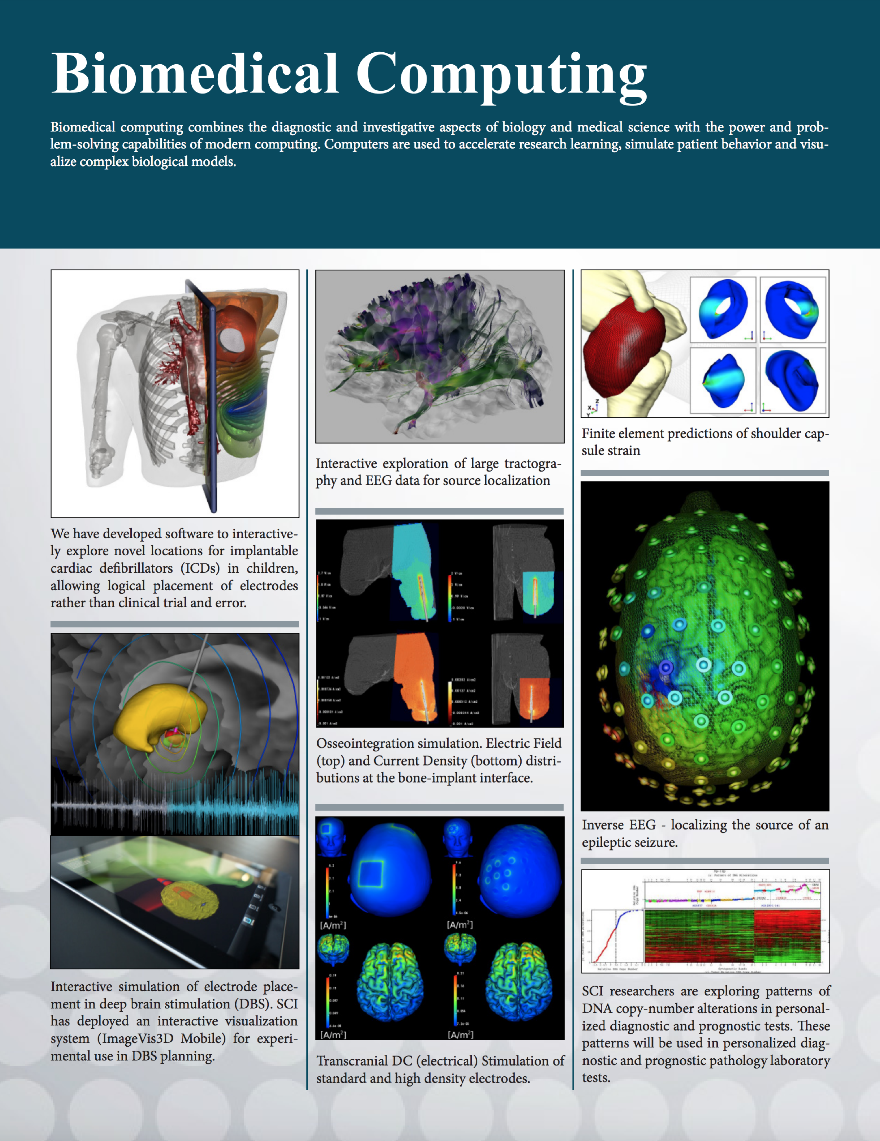

~CAPTION~ A Brief summary of the research projects undertaken by the SCI Institute in the field of biomedical computing. ETC

We have used machine learning to detect changes in the cardiac signal that indicate the first signs of a heart attack. Our approach isolates the electrical signals from the heart and examines changes before, during, and after simulated heart attacks. The computer then reads these signals and categorizes the data. The two categories the computer isolates are “having a heart attack” and “not having a heart attack.” Compared to traditional human metrics the computer performs 10% faster in determining when you are having a heart attack. The computer is also more accurate and correctly detected the early signs of a heart attack 32% more often. Each episode detected by the machine learning algorithm on top of those seen using the traditional measures is a potentially averted misdiagnosis. Our algorithm is capable of focusing on different regions of the ECG depending on how said region changes due to the underlying stress.

* ~~These episodes (32%) captured by our algorithm, and not the traditional method, would have been considered ‘silent’ and may have led to misdiagnosis~~
* ~~Our algorithm uses the entire signal (rather than just a single time point) and chooses the most responsive region of the signal to make the diagnosis~~

The Future of Heart Attack Detection

WHY HASN’T THIS CHANGED FOR A CENTURY?

* Accessing a beating heart was seen as impossible by the majority of the field for 50 years
* Computational power has severely limited the analytics possible within a decision making time frame (when you couldn’t filter signals live, ST segment changes were all you could see :P)
* Now computational power allows you to perform machine learning essentially live.

Using machine learning to help physicians detect heart attacks is a huge advancement in the field of cardiology. This advancement provides physicians and healthcare workers another tool to better detect and treat you during one of life’s most dire circumstances. Incorporation of this tool will protect all Americans at risk of heart attacks from genetic predispositions or environmental factors. This work, in conjunction with others, could hold the key to understanding and detecting heart attacks, making death from heart attacks a thing of the past. Next time you visit your physician for chest pain check who their partner is, it may just be a computer.